Estimating the Solar Potential for the Land Recovery, Inc landfill in Graham, Washington. Demonstration of PVWatts, RE-Powering Mapper, and Re-Powering’s Decision Tree Tool.

Provided by: Karl Oleson

Date: 12/8/23

Contents

Task 1

Background 1

Information from Re-Powering Mapper 3

Information from Re-Powering’s Decision Tree Tool 4

Information Supplied to PVWatts 5

Results from PVWatts 7

System Production Context 8

Task

Assess the maximum solar harvesting capability of Land Recovery, Inc.’s (LRI) brownfield landfill site in Graham, Washington as part of the site’s redevelopment plan. Use PVWatts, RE-Powering Mapper, and Re-Powering’s Decision Tree Tool to conduct the analysis.

# Background

According to the Washington State Department of Ecology, brownfield sites are, “… abandoned or underutilized properties that may have environmental contamination. Brownfields are common in communities of all sizes — they may be old gas stations, drycleaners, industrial facilities, smelters, or former agricultural land.”1 Such sites can be found with the U.S. EPA RE-Powering America’s Land Initiative Mapper (RE-Powering Mapper) which “…provides federal and state data for over 190,000 brownfields, Superfund, landfill, mine sites and other contaminated [lands](https://geopub.epa.gov/repoweringApp/cdn/18/) to help users identify sites for renewable energy development.”2

One such location which can be found with the mapper is LRI’s landfill site in Graham, WA. 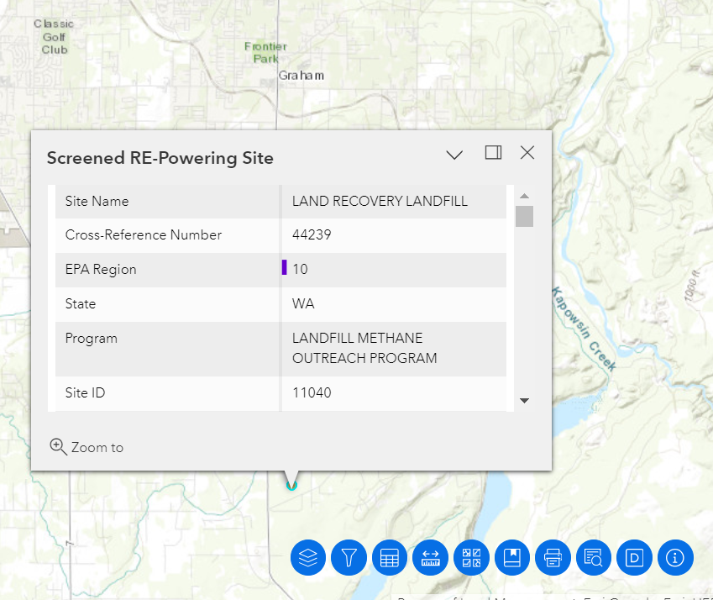

**Figure 1**: Screenshot of the RE-Powering Mapper site information.

Further investigation will find that this is a 320-acre site with a 168-acre landfill footprint3. The contract is expected to be filled/end before 2036. The site currently covers the landfill material and captures the methane to power nearby homes.

This assessment will use PVWatts and Re-Powering’s Decision Tree Tool to estimate how much solar energy could be harvested after this site is filled.

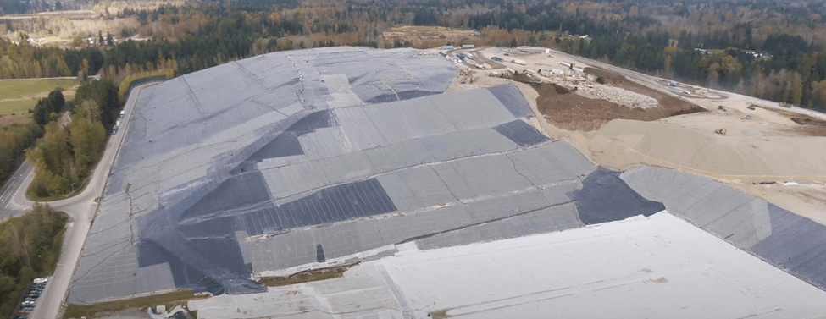3

**Figure 2**: Recent aerial picture of the site.

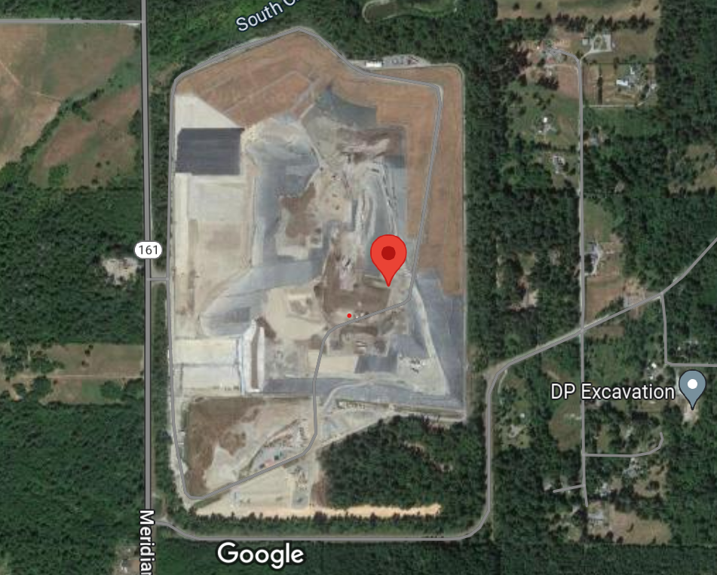4

**Figure 3**: Google maps view of the site.

**Sources:**

1. https://ecology.wa.gov/spills-cleanup/contamination-cleanup/brownfields#:~:text=Brownfields%20in%20Washington,smelters%2C%20or%20former%20agricultural%20land.
2. https://geopub.epa.gov/repoweringApp/
3. <https://www.piercecountywa.gov/7972/Landfill-Information>
4. Google Maps Location: 46.971553, -122.290575

# Information from Re-Powering Mapper

The Re-Powering Mapper contains initial assessments of the renewable energy potential at brownfield sites. It reports this site is located at 46.971000, -122.290500 and has a potential for 24.35 MW of solar capacity. The Maximum Annual GHI (kWh/m2/day) is only 3.31 however, which is below the 3.5 threshold commonly used by developers. The mapper further reports the distance to the nearest substation is 2.15 miles with that substation voltage at 115V and the distance to the nearest transmission line is 0.34 miles. Additionally, the distance to the nearest road is reported at 0.06 miles and the landfill is currently in service.

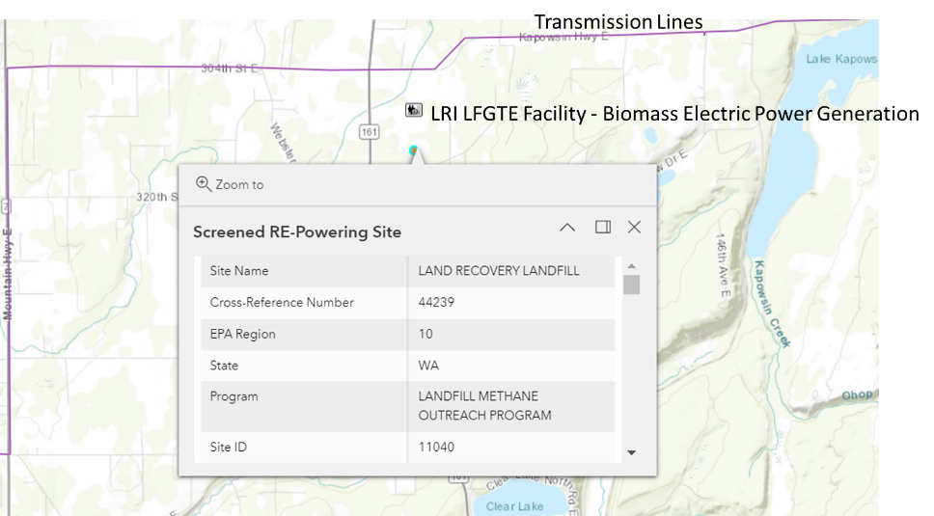

**Figure 4**: Identification of the nearest transmission lines and proximity to an existing biomass electric power generation station.

# Information from Re-Powering’s Decision Tree Tool

RE-Powering’s Decision Tree Tool is a program which helps developers walk through various complications of using brownfield sites for energy generation.

Below are notable inputs for the Decision Tree Tool. The results from the tool are provided further below.

* Site Type: Landfill
* Technology: Solar PV
* Installation Type: Ground Mount
* Is this site in the northwest corner of Washington State or Alaska: No
* Enter Usable Acreage (optional): 168
* Is the distance to transmission and/or distribution lines less than 1 mile: Yes
* Enter distance (miles) (optional): 0.34
* Is the distance to graded road less than 1 mile: Yes
* Enter distance (miles) (optional): 0.06
* Is the site owner(s) interested in investing in and/or selling or leasing the site in order to enable development of solar PV: Skip
* Is there an existing redevelopment plan for the site or is one being developed: Skip
* Will a community visioning process be part of the site’s redevelopment: Skip
* Is the site free of land use exclusions or restrictions that would preclude the use of solar PV on the usable acreage or rooftop: Skip
* Is the landfill or portions of the landfill being considered for solar PV closed consistent with applicable requirements: No.
* Is there a closure plan for the landfill: Skip
* Select a renewable energy project arrangement: Sell Power to Utility
* Is the local utility or other energy provider interested in buying power from a renewable project at the site: Skip

**Figure 5**: Results from the Re-Powering ‘s Decision Tree Tool. Further investigation into whether the responsible entities would be interested in this project is recommended before proceeding.

The tool needs to have more questions answered before a clear determination can be made. The tool recommends filling in missing information such as determining if the local utility is interested in buying the solar and if there is an existing redevelopment plan first before approving the project. The tool’s recommended next steps are shown below.

**Figure 6**: Reported next steps from the decision tree tool.

# Information Supplied to PVWatts

The Rooftop Size Estimator in PVWatts can be used to draw a perimeter around a site and estimate the site’s footprint. The estimator estimates the current landfill is 651140 m2 of used space, or approximately 161 acres. PVWatts further identifies a potential system capacity of 97.7MW if all the area was covered. This is significantly higher than the recommended 24MW from the RE-Powering Mapper.

**Figure 7**: PVWatts’ Rooftop Size Estimator’s estimate of the area of the site and potential size of a system.

However, it is more realistic to only consider the southern facing side of the mound for solar panel installation. Panels on the east, west, and north slopes are unlikely to be a good return on investment due to shading. A more practical system would cover the southern space outlined below. This system size of 32.5MWdc more closely matches the 24MW recommendation from the RE-Powering Mapper.

A better estimate of a reasonable footprint should be informed with GIS information. It is currently difficult to precisely determine the coordinates of the southern face and the characteristics of the summit. The current estimate may be too high due to incorrect placement of the ridge between the southern and western faces. It is also possible the current estimate is too low due to underestimation of the usable space at the summit.

**Figure 8**: PVWatts’ Rooftop Size Estimator’s estimate of the area of the southern facing slopes of the site and potential size of a system.

PVWatts parameters for the analysis are shown below. Results for both 2-axis tracking and fixed tilt scenarios were simulated. The fixed tilt angle was varied from 10ᵒ to 45ᵒ to locate the optimum angle. Default parameters are otherwise used for this quick analysis.

**Figure 9**: Input into PVWatts. Defaults values are used for this initial assessment unless otherwise mentioned.

# Results from PVWatts

PVWatts predicts a maximum of 46,650,081 kWh/year potential from this site with a 2-axis tracking system. Summary results are shown below.

**Figure 10**: Output from PVWatts with 2-axis tracking system. An annual production of 46,650,081 kWh/year is predicted.

Using a fixed (open rack) system shows an optimum at 33,946,028 kWh a year.

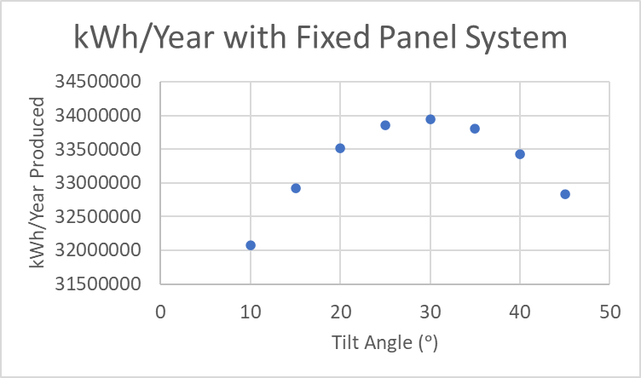

**Figure 11**: Plot of Tilt Angle vs. kWh/Year Produced for a fixed tilt system. A tilt angle of approximately 30 degrees is recommended with 34,000,000 kWh a year of solar potential.

# System Production Context

According to energysage.com5, the average Washington household uses 11,736 kWh a year. The dual-axis tracking system hypothetically could provide electricity for 3,975 homes while a fixed tilt system could provide equivalent electricity for 2,892 homes.

**Source:**

1. https://www.energysage.com/local-data/electricity-cost/wa/#:~:text=That's%2028%25%20lower%20than%20the,the%20course%20of%20the%20year.